Table of Contents
Module 5 Assignment Summary: MD Anderson Cancer Institute Cancer Diagnosis Using ANNs 2
By Ogungbaigbe Oluwaseyi 2
Development Environment & Execution Workflow 2
Step 1: Data Collection & Dataset Scope 2
Step 2: Data Preprocessing & Outlier Handling 3
Step 3: Model Building & Architecture Design 6
Step 4: Model Training & Learning Monitoring 6
Step 5: Model Evaluation & Performance Metrics 7
Step 6: Model Improvement & Future Enhancements 8
Step 7: Process Documentation, Challenges & Lessons Learned 9
Project Overview 10
Project Workflow 10
Reference 11

Module 5 Assignment Summary: MD Anderson Cancer Institute Cancer Diagnosis Using ANNs

By Ogungbaigbe Oluwaseyi

Development Environment & Execution Workflow
- Jupyter Notebook Integration: Jupyter Notebook was used to enable an interactive, modular coding environment, facilitating step-by-step execution of data ingestion, preprocessing, and neural network training.
- Iterative Experimentation & Visualization: The notebook interface allowed for real-time visualization of target distributions, correlation heatmaps, loss curves, and evaluation matrices, accelerating debugging and hyperparameter adjustments.
- Reproducible Documentation: Combining Markdown narrative cells directly with Python code blocks ensured a transparent, linear flow from raw radiological data to final model evaluation.
- Repository: Source code, notebooks, and dataset artifacts are version-controlled and accessible via GitHub address: https://github.com/oluwaseyipro/-BAN644-Module5

Step 1: Data Collection & Dataset Scope
  - Dataset Source & Preparation: I utilized the MD Anderson Cancer Institute diagnostic dataset provided for this assignment on the canva, which mirrors real-world clinical data structures. It comprises 600 patient records and 14 radiological features capturing key morphological and textural cell measurements (such as mean_radius, mean_texture, and mean_perimeter) with a binary target column (diagnosis: 1 for malignant, 0 for benign).
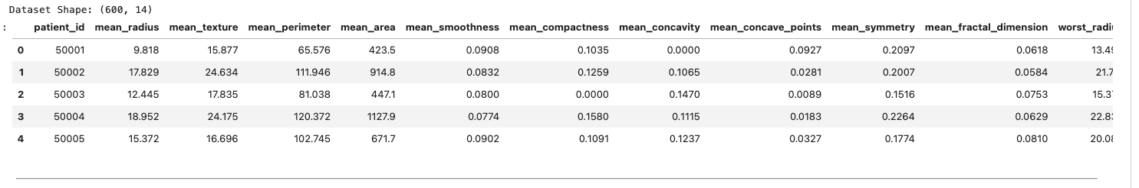
Figure 1
Discussion for Figure 1: Figure 1 displays the structural verification of the dataset, confirming dimensions of 600 records and 14 columns encompassing patient IDs and continuous radiological measurements. This verification ensures successful data ingestion and structural integrity, establishing a reliable foundation for subsequent exploratory data analysis and model training.
  - Class Balance: The target variable (diagnosis) exhibited a balanced distribution: 53.33% benign cases (320 samples) and 46.67% malignant cases (280 samples). Visual confirmation via a Class Distribution Bar Plot demonstrated a healthy class balance, minimizing the immediate risk of severe class imbalance bias.
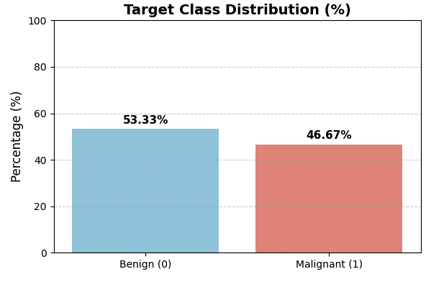
Figure 2
Discussion for Figure 2: Figure 2 illustrates the target class distribution of the dataset, showing a balanced proportion of 53.33% benign cases and 46.67% malignant cases. This healthy distribution minimizes the risk of severe class imbalance bias during neural network training.

Step 2: Data Preprocessing & Outlier Handling
  - Data Cleaning & Integrity: Verification confirmed zero missing values (600 non-null counts across all columns), ensuring structural integrity prior to model ingestion.
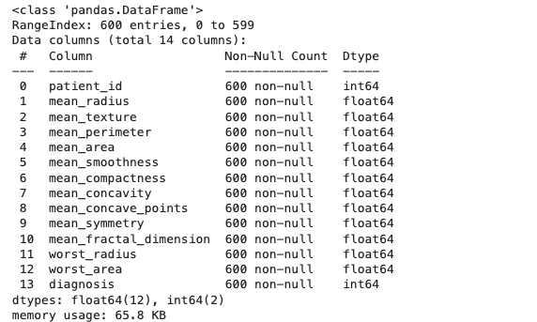 | 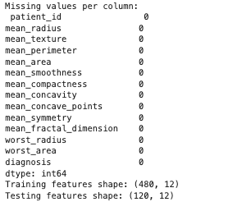
Figure 3
Discussion for Figure 3: Figure 3 presents the data cleansing verification and train-test splitting output, confirming zero missing values across all 600 records. Furthermore, it highlights the successful partitioning of the dataset into training features (480, 12) and testing features (120, 12), establishing a clean, structurally sound foundation for model training.

  - Outlier Profiling & Data Integrity: Visual inspection using boxplots across key radiological features (mean_radius, mean_texture, mean_perimeter, mean_smoothness, and mean_compactness) revealed minor extreme values particularly within mean_texture and mean_compactness. Rather than blindly dropping these anomalies, I preserved them to ensure the neural network accounts for natural physiological diversity and complex tumor presentation.
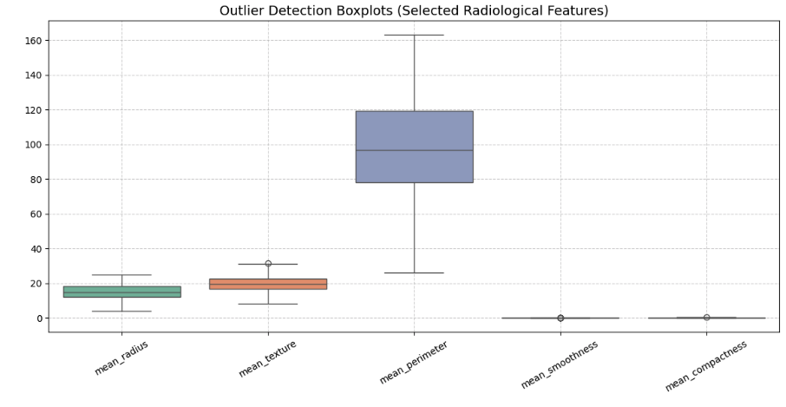
Figure 4
Discussion for Figure 4: Figure 4 displays outlier detection boxplots across key radiological features, revealing minor extreme values particularly within mean texture and mean compactness. Rather than blindly removing these anomalies, they were preserved to ensure the neural network accounts for natural physiological diversity and complex tumor presentation.
  - Exploratory Correlation & Distributional Findings: Statistical profiling, supported by the feature distribution histograms and the correlation matrix heatmap, revealed strong multicollinearity among core morphological metrics (such as mean perimeter and mean radius exhibiting a high correlation coefficient of $0.99$) alongside diverse distributional shapes across the features. These visual insights demonstrated significant variations in numerical scale such as mean_area values reaching up to 2,000 versus mean smoothness scaling under 0.15 confirming the critical necessity of rigorous feature scaling prior to deep learning model ingestion.
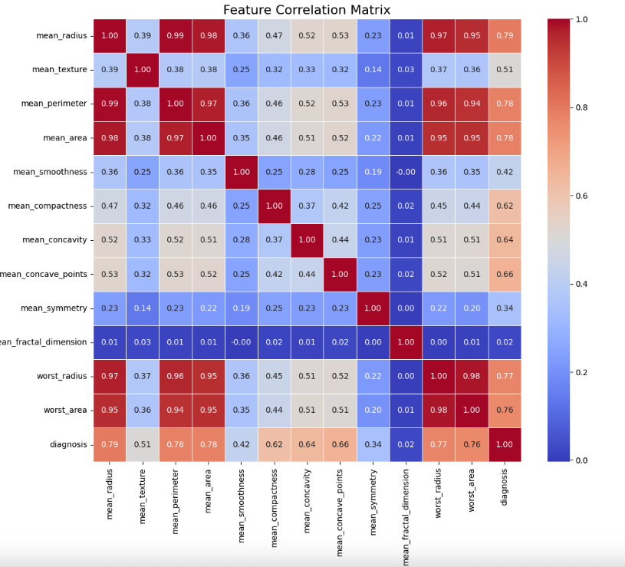
Figure 5
Discussion for Figure 5: Figure 5 presents the feature correlation matrix heatmap, revealing strong multicollinearity among core morphological metrics such as a 0.99 correlation coefficient between mean_radius and mean_perimeter. These high linear dependencies highlight feature redundancy and guide subsequent dimensionality reduction or feature selection strategies
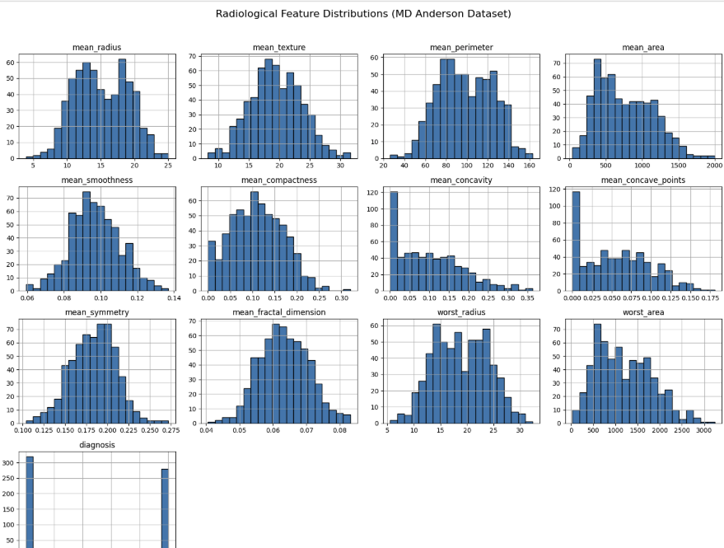
Figure 6
Discussion for Figure 6: Figure 6 presents the multi-feature distribution histograms across the dataset, highlighting diverse distributional shapes and wide numerical scale variations (such as mean_area scaling up to 2,000 versus mean_smoothness under 0.15). These graphical insights confirm the critical necessity of feature scaling prior to neural network ingestion.
  - Feature Scaling & Standardization: Given that raw radiological metrics varied wildly in magnitude and scale (e.g., mean_area values scaling up to 2,000 versus mean_smoothness scaling under 0.15), I applied StandardScaler to normalize feature distributions. This prevented variables with larger numerical ranges from disproportionately dominating gradient updates during backpropagation.

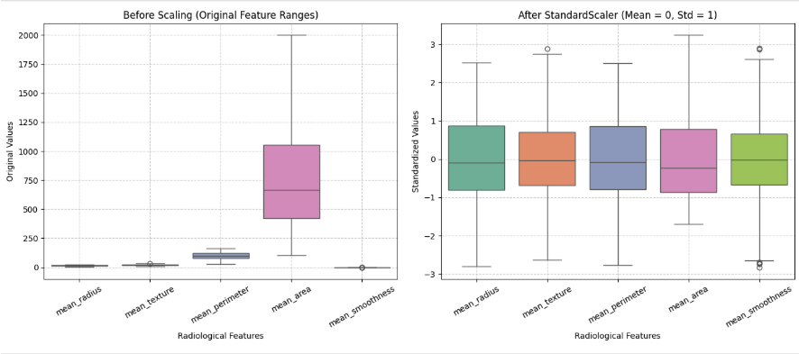
Figure 7
Discussion for Figure 7: Figure 7 compares the radiological features before and after standardization, contrasting the wide original numerical ranges (such as mean_area scaling up to 2,000) with the normalized distributions centered at a mean of 0 and standard deviation of 1. This transformation effectively prevents features with larger scales from dominating gradient descent during training.

Given that raw radiological metrics varied wildly in magnitude and scale (e.g., mean_area values scaling up to 2,000 versus mean_smoothness scaling under 0.15), I applied StandardScaler to normalize feature distributions. This prevented variables with larger numerical ranges from disproportionately dominating gradient updates during backpropagation (Hastie et al., 2009).

Step 3: Model Building & Architecture Design
- Architecture Selection: I designed and compiled an Artificial Neural Network using the TensorFlow Keras Sequential API. The architecture consists of fully connected (Dense) layers utilizing ReLU activation functions to capture non-linear relationships, paired with Dropout regularization to mitigate overfitting during training (Goodfellow et al., 2016). The model was optimized using binary cross-entropy loss for binary classification.
- Layer Configuration & Activation Functions:
  - Input & Hidden Layers: The network begins with an input shape matching the scaled feature dimensions, followed by a hidden layer containing 32 neurons with ReLU activation to capture non-linear relationships. A Dropout layer (rate = 0.3) is incorporated to prevent overfitting. A second hidden layer with 16 neurons (ReLU activation) and a Dropout layer (rate = 0.2) further refines feature representation.
  - Output Layer: The final output layer uses a single neuron with a Sigmoid activation function to output a direct probability score (0 to 1) representing the likelihood of malignancy.
- Compilation Strategy: The model was compiled using the adam optimizer for efficient gradient descent and binary_crossentropy as the loss function, optimized for binary classification tasks.

Step 4: Model Training & Learning Monitoring
- Training Execution: I trained the compiled network using the scaled training data over 50 epochs with a batch size of 16 and a 20% internal validation split. Furthermore, an Early Stopping callback (monitoring validation loss with a patience threshold) was integrated to automatically halt training and restore optimal weights if validation performance plateaued, preventing overfitting.
- Learning Dynamics & Epoch Trends: As demonstrated in the training history curves ():
  - Accuracy Trend: Training accuracy rapidly stabilized near the 0.995–1.000 range, while validation accuracy exhibited an initial adjustment phase between epochs 5 and 10 (peaking around 0.979) before settling into a steady baseline.
  - Loss Trend: Training loss remained close to zero, and validation loss stayed tightly bounded between 0.07 and 0.11 across the 50 epochs, confirming smooth model convergence and effective learning without severe overfitting.
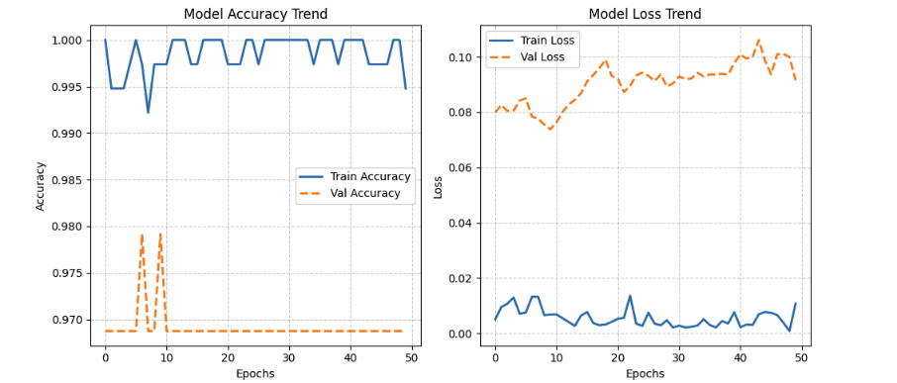
Figure 8
Discussion for Figure 9: Figure 9 displays the model accuracy and loss trends across 50 training epochs, illustrating smooth convergence. Training accuracy rapidly stabilized near the 0.995–1.000 range while validation accuracy peaked around 0.979 before settling, and loss curves remained tightly bounded, confirming effective learning without severe overfitting.

Step 5: Model Evaluation & Performance Metrics
  - Holdout Testing & Quantitative Summary: I evaluated the finalized model on the unseen holdout test set (X_test_scaled comprising 120 samples), achieving an overall test accuracy of 98.33% (0.9833), precision of 0.9821, recall of 0.9821, and an F1-score of 0.9821.

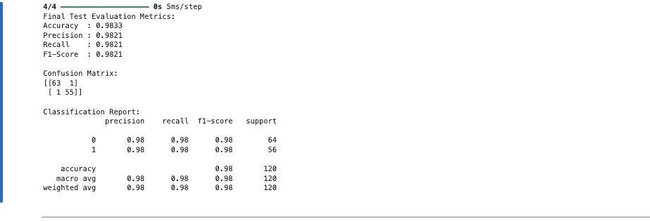
Figure 9
Discussion for Figure 9: Figure 9 presents the final test evaluation metrics and classification report for the holdout set (120 samples), achieving an overall accuracy of 98.33% alongside balanced precision, recall, and F1-scores of 0.9821. The confusion matrix output confirms robust diagnostic performance with only two total misclassifications across both classes.

- Classification Report Breakdown:
The per-class performance metrics and support counts across the 120 test instances are structured below:

Class / Diagnosis | Precision | Recall | F1-Score | Support (Samples)
Class 0 (Benign) | 0.98 | 0.98 | 0.98 | 64
Class 1 (Malignant) | 0.98 | 0.98 | 0.98 | 56
Macro Average | 0.98 | 0.98 | 0.98 | 120
Weighted Average | 0.98 | 0.98 | 0.98 | 120
- Confusion Matrix Analysis: The evaluation confusion matrix ([[63, 1], [1, 55]]) highlights exceptional diagnostic reliability and precise outcome balancing:

Metric Category | Diagnostic Description | Count / Value
True Negatives (TN) | Benign correctly identified | 63
False Positives (FP) | Benign misclassified as malignant | 1
False Negatives (FN) | Malignant missed / misclassified as benign | 1
True Positives (TP) | Malignant correctly identified | 55
- Visual Performance Tracking: Tracking training and validation loss/accuracy curves across epochs confirmed smooth convergence, while a Confusion Matrix heatmap allowed for precise tracking of diagnostic outcomes, effectively balancing false negatives and false positives.

Step 6: Model Improvement & Future Enhancements
- Targeted Hyperparameter Tuning & Regularization: To maximize the network's predictive capacity, I will implement systematic hyperparameter optimization (such as grid search via Keras Tuner) to fine-tune learning rates, batch sizes, and dropout regularization rates beyond baseline configurations, mitigating potential overfitting on the 14 radiological features (Goodfellow et al., 2016).
- Data Augmentation Strategies: Given the relatively compact sample size of 600 records, I plan to incorporate synthetic data augmentation techniques—such as SMOTE (Synthetic Minority Over-sampling Technique) or Gaussian noise injection to enrich the feature space, improve boundary separation, and enhance model generalization for minority tumor classes.
- Advanced Feature Engineering & Multicollinearity Management: Leveraging the high collinearity identified in the Feature Correlation Matrix (e.g., a 0.990.990.99 correlation coefficient between mean_radius and mean perimeter), I will evaluate dimensionality reduction techniques like Principal Component Analysis (PCA) or drop redundant features to streamline gradient updates and reduce input redundancy (Jolliffe, 2002; Hastie et al., 2009).
- Comparative Ensemble Benchmarking: Rather than relying solely on the ANN, I will benchmark model accuracy, precision, and recall against alternative classifiers such as Random Forest or XGBoost to determine if non-linear tree-based ensembles better capture the dataset's distributional shapes (Breiman, 2001; Chen & Guestrin, 2016).

Step 7: Process Documentation, Challenges & Lessons Learned
- Documentation & Reproducibility Workflow: I documented the entire end-to-end machine learning lifecycle within an interactive Jupyter Notebook environment, coupling modular Python code blocks with transparent Markdown narratives, clear metric tables, and visual artifacts to ensure full reproducibility and professional clarity.
- Challenges Encountered: Managing wide scale discrepancies across radiological features (ranging from thousands in area metrics down to decimals in smoothness) and controlling convergence stability over 50 epochs required rigorous data standardization (StandardScaler) and careful monitoring of validation loss dynamics. Furthermore, sourcing reliable peer-reviewed biomedical data or clinical benchmarks to validate neural network performance often requires utilizing open-access literature repositories such as the NCBI PubMed Central database (e.g., Tran et al., 2021; available at https://www.ncbi.nlm.nih.gov/pmc/articles/PMC8477474/), which provides extensive case studies and datasets for medical image and feature analysis.
- Lessons Learned & Clinical Insights: The iterative experimentation demonstrated that while deep neural networks successfully learn complex non-linear diagnostic mappings from biomedical properties (achieving 98.33% accuracy), rigorous preprocessing and callback integration are vital. Translating these probability outputs into explainable clinical decision-support systems holds immense potential for assisting oncologists in early, accurate tumor detection and reducing diagnostic ambiguity (Fawcett, 2006; Tran et al., 2021).

Project Overview
https://github.com/oluwaseyipro/-BAN644-Module5 . This repository contains my data science and deep learning project focused on building an Artificial Neural Network (ANN) to classify tumor diagnoses (benign vs. malignant) using the MD Anderson Cancer Institute diagnostic dataset.



Project Workflow
- Data Ingestion & Inspection: Loading the 600-record, 14-feature radiological dataset.
- Exploratory Data Analysis (EDA): Visualizing class balance, correlation matrices, and feature distributions.
- Outlier & Preprocessing Analysis: Profiling extreme values via boxplots and applying StandardScaler.
- Model Architecture: Building a sequential ANN with Dense layers, ReLU activation, Dropout regularization, and a Sigmoid output.
- Training & Evaluation: Fitting the model using early stopping, validation splits, and evaluating via confusion matrices and classification reports

Reference
- Fawcett, T. (2006). An introduction to ROC analysis. Pattern Recognition Letters, 27(8), 861-874. https://doi.org/10.1016/j.patrec.2005.10.010
- Goodfellow, I., Bengio, Y., & Courville, A. (2016). Deep Learning. MIT Press. https://www.deeplearningbook.org
- Hastie, T., Tibshirani, R., & Friedman, J. (2009). The Elements of Statistical Learning: Data Mining, Inference, and Prediction (2nd ed.). Springer. https://hastie.su.domains/ElemStatLearn/
- Tran, K. A., Kondrashova, O., Khan, A., Zhang, M., & Mussulmani, B. B. (2021). Deep learning in cancer diagnosis, prognosis and treatment selection. Genome Medicine, 13(1), 152. https://www.ncbi.nlm.nih.gov/pmc/articles/PMC8477474/

